2020 ANNUAL MEETING OF THE
BOARD OF DIRECTORS
December 17, 2019

Brownson Country Club, Shelton, Connecticut

The 2020 Annual Meeting of the Shelton Economic Development Corporation was held on Tuesday, December 17, 2019 at 8:30 AM at Brownson Country Club with the following directors present:
Pat Carey | Michelle Kawalautzki | Fred Ruggio
Madelyn Cerritelli | Mayor Lauretti | Ruth Parkins
Alberto Martins | Angelo Melisi | Liz Schultz
Al Paolozzi | Janice Sheehy | Ed McCreery

Also Attending:
Gil Apicella | Rep. Ben McGorty | Jerry Romano | Patrick McMahon
Anthony Simonetti | Jim Tate | Alan Tyma, Esq. | John Guedes
Marianne Sheehan | John Guedes | Bill Purcell | Neil Thurber, AECOM
Neil Thurber, AECOM | Laura NSB | Aleta Miner | Dominick Cerritelli
Amy Cobaugh | Ray Oppel | Paul Grimmer

GREETING – Paul Grimmer, President
At 8:45 AM Mr. Grimmer decided to open the meeting of the 37th Annual Meeting. However, a quorum was not met.

APPROVAL OF MINUTES (Quarterly Meeting – 10/8/19) – NO ACTION TAKEN

Mr. Grimmer asked Alberto Martins, SEDC’s Treasurer, to present this morning’s Financial Report.

FINANCIAL REPORT – Alberto Martins, Treasurer
On behalf of the SEDC, Mr. Martins provided a breakdown of the financials year to date as of the month of November.

The budget was reviewed. The budget is comparable to last year and was recently approved by the Executive Committee and staff believes it is realistic for the coming year. NO ACTION WAS TAKEN.

NOMINATING REPORT – Pat Carey – NO ACTION WAS TAKEN

PROGRAM REPORT – Paul Grimmer, President
Mr. Grimmer welcomed everyone. Paul introduced State Rep. Ben McGorty and also acknowledged SEDC staff.

OUR TEAM
Paul J. Grimmer, President acknowledged the SEDC Team which included:
Aleta Miner, Assistant to the President Marianne Sheehan, Secretary
Amy Cobaugh, Secretary Ed Kisluk, Support Staff,
Fred Ruggio, EDC, Chairman Guy Beardsley, Citizens Advisory Bd, Chairman
Raymond Oppel, Raymond A. Oppel, CPA David Wojtowicz, Auditor, CPA and
Attorney Francis Teodosio,Teodosio & Stanek

Paul Gimmer stated that he wished to begin the presentation by highlighting the specific achievements of the City’s brownfields redevelopment effort.

President’s Report

2019 – A Year in Review 2020 – Light at the End of the Tunnel
- Public & Private Leveraging Canal Street North
- Return on Investment Road Engineering/Reconstruction
- Economic Expansion Downtown Planning Program
- Taxes

Canal Street Reconstruction / Remediation Public
Funding vs. Private Investment
Paul Grimmer recognized the public funding efforts related to the Shelton Brownfields Activities along Canal Street which included funding of $24,544,780 dating back to 1996 along with leveraged private finances of $86,000,000 (Est.) from developments along Canal Street. Paul Grimmer acknowledged that Bridge Street Commons is located at the corner of Bridge Street and Howe Avenue. See Breakdown below.

Partners | Public Funding |  | Private Investment | Private Investment
City of Shelton | $9,013,310.00 |  | Birmingham Condo’s | $18,000,000.00
CT DECD | $10,168,470.00 |  | Avalon Shelton | $35,000,000.00
CT DOT | $2,095,000.00 |  | Bridge Street Commons | $9,500,000.00
NVCOG | $278,000.00 |  | River Breeze Apartments | $12,000,000.00
US EDA | $1,000,000.00 |  | Canal Bridge Lofts | $8,000,000.00
US EPA | $1,680,000.00 |  | Riverside Commercial | $3,500,000.00
Rotary Club | $170,000.00
Regional Partners | $140,000.00
Total Received | $24,544,780.00 |  | Total Leveraged | $86,000,000.00

Paul Grimmer stated that three properties have been developed, including Birmingham Condos, Avalon Apartments and Bridge Street Commons. Together these three projects created 401 residential units and generate real estate taxes revenue in excess of $906,000. Since these properties have been developed and subsequently taxed, they have generated city tax revenue of approximately $5,756,565, which is roughly 64% of the all the monies spent by the City. The City of Shelton Planning & Zoning Commission has approved an additional eight projects which will help to create another 396 residential units. By 2021, the City of Shelton can expect tax revenues to double as it generates taxes of over $1,804,000 per year. Thus by 2022, all of the City’s brownfields expenditures will have been fully paid back.

Annual Tax Revenues 1997-2018
Complex | Annual Tax Receipts | # of Units | Avg. Tax/Unit | Year Online | Year Taxed | Est. Taxes  Collected
Birmingham Condos | $298,914 | 103 | $2,902.00 | 2007 | 11 | $3,288,053
Avalon  Apartments | $465,163 | 250 | $1,860.00 | 2013 | 5 | $2,325,816
Bridge St.  Commons | $142,696 | 48 | $2,972.00 | 2017 | 1 | $142,696
Annual Taxes | $906,773 | 401 | $2,266.00 |  | Total  Taxes | $5,756,565

Downtown Development
Approved/Pending Activities
Location | Type | Units | $$ Investment $$
523 Howe Avenue - Botti | Mixed Use | 12 | $2,100,000
509 Howe Avenue – Calandro | Mixed Use | 27 | $3,725,000
427 Howe Avenue – Melisi | Mixed Use | 80 | $14,000,000
434 Howe Avenue – Matto (TBD) | Mixed Use | - | TBD
366 Howe Avenue – Pettis | Mixed Use | 25 | $4,375,000
320 Howe Avenue – Cedar Village at Carroll’s | Mixed Use | 33 | $6,000,000
62 Center Street – Jeff’s Appliance | Mixed Use | 42 | $7,350,000
235 Canal Street – Riverview Square | Residential | 23 | $4,025,000
Est. Additional Tax Revenue - $897,336 | Total | 396 | $41,575,000

Canal Street Reconstruction/Remediation - Public Funding vs. Private Investment
Partners | Public Funding | Private Investment | Private Investment
City of Shelton | $9,013,310.00 | Birmingham Condos | $18,000,000.00
CT DECD | $10,168,470.00 | Avalon Shelton | $35,000,000.00
CT DOT | $2,095,000.00 | Bridge Street Commons | $9,500,000.00
NVCOG | $278,000.00 | River Breeze Apart. | $12,000,000.00
US EDA | $1.000.000.00 | Canal Bridge Lofts | $8,000,000.00
US EPA | $1,680,000.00 | Riverside Commercial | $3,500,000.00
Rotary Club | $170,000.00 | All Others | $41,575,000.00
Regional Partners | $140,000.00 | Est. Tax Revenue  $1,804,000
Total Received | $24,544,780.00 | Total Leveraged | $127,575,000.00

Canal Street Browfields Redevelopment - Property Demographics
Pro ID | Address/Map/Lot | Property | Owner | Acreage | Addressed | Comp. | In Pro  gress | Not Started
1 | 0 Canal St./139/3 | Ascom  Hasler | Alegna  Corp. | 1.87 |  |  |  | 1
2 | 281 Canal St./139/4 | Star Pin | City | 1.40 | 1 |  | 1
3 | 255 Canal St./139/5 | Better  Pkgs Lot | Better  Pack. | 1.00 | 1 |  | 1
4 | 235 Canal St./129/17 | Apex  Tool | Alegna  Corp. | 1.30 | 1 | 1
5 | 223 Canal St./129/18 | River Breeze  Apts. | Mutual  Housg | 1.26 | 1 | 1
6 | 185 Canal St./129/19 | Avalon | Avalon  Bay | 4.44 | 1 | 1
7 | 145 Canal St./129/20 | Birm. Condo | Birm.  Assoc. | 0.80 | 1 | 1
8 | 0 Canal St./129/21 | Canal Bdge  Lofts | Rudy  Pizzoferrato | 1.04 | 1 | 1
9 | 0 Canal St./130/2 | Rolfite | Primrose Co. | 1.67 | 1 | 1
10 | 123 Canal St./130/3 | Samarius Land | City | 0.39 | 1 | 1
11 | 0 Canal St./130/4 | Chromium Land | City | 0.30 | 1 | 1
12 | 0 Canal St./130/5 | Axton Cross Land | City | 0.59 | 1 | 1
13 | 0 Canal St./130/6 | Axton Cross  Land | City | 0.35 | 1 | 1
14 | 0 Canal St./130/7 | Cel-Lastik  Land | City | 1.08 | 1 | 1
15 | 113 W. Canal  St./129/31 | Chrom.  Process Pkg | City | 0.64 | 1 | 1
16 | 130 Canal St./130/1 | Shelton  Farm & Mkt | City | 0.30 | 1 | 1
17 | 0 Canal St./118/38 | Vet. Mem.  Bank (Riverbank) | City | 1.62 | 1 | 1
18 | 0 Canal St./118/37 | Vet. Mem.  Park | Cit7 | 5.55 | 1 | 1
 |  |  |  | 25.60 | 17 | 14 | 2 | 1
 |  |  |  | Acres | 25.60 | 21.33 | 2.40 | 1.87
Public/Private Reuse
Public Open Space

- Veterans Memorial Park
- Housatonic Riverwalk
- Shelton Farm & Public Market
- Rotary Pavilion
- War Memorials (The Big Four)
- Civil War Memorial
- Properties Remediated – 4
- Total acreage – 8.55
- Supports 100,000+ Users – Annually

Slides were shown of the different public spaces.
Shelton Economic Development Corp.
Current Program Activities
- 267 Canal Street – Star Pin Factory
- Site Assessment/Remediation
- 223 Canal Street – River Breeze Commons
- Site Assessment/Remediation/Demolition
- Wooster Street/Canal Street Reconstruction
- Engineering & Desing
- Area Wide Assessment Grant
- Apex Tool (Completed)
- Autoswage (Completed)
- Grant Close-Out 12/31/19
- Comprehensive Economic Development Strategy
- Administration of the 20 Town CEDS Program
- $70,000 CEDS Grant – Formal Announcement – 12/13/2019
- Valley Community Foundation’s John Tyma Fund-3 Year Grant Commitment ($15,000/Year)

Star Pin Factory, 267 Canal Street - Site Assessment
CT DECD – Assessment $200,000 CT DECD – Remediation $750,000 Tighe & Bond
- Phase 1 Environmental Site Assessment (ESA) Completed
- Phase II/ III ESA Underway – Estimated Completion April 2020
- Chemical Assessment – US Ecology – Start Date January 1, 2020 (30 Days)
- Will Seek Pricing for Removal of Catalogued Chemicals Upon Completion
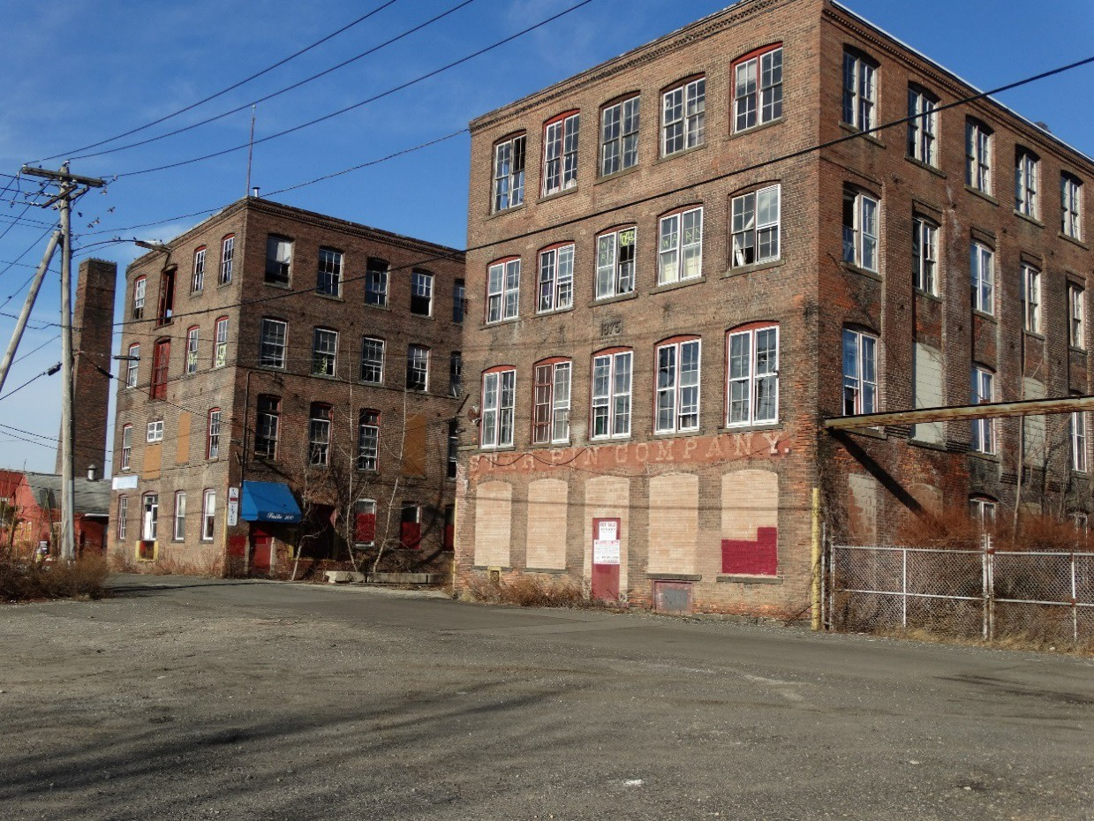

Star Pin Factory, 267 Canal Street - Remediation
CT DECD – Assessment $200,000 CT DECD – Remediation $750,000
- Primary Use of Funds – Remediation of Hazardous Building Material from Structure
- Received Pricing for Engineering Services
- Prepare Technical Bid Specifications / Support
- Project Oversight
- Engineer Selection – Jan. 2020
- Out to Bid – March 2020
- Project Completion – July 2020

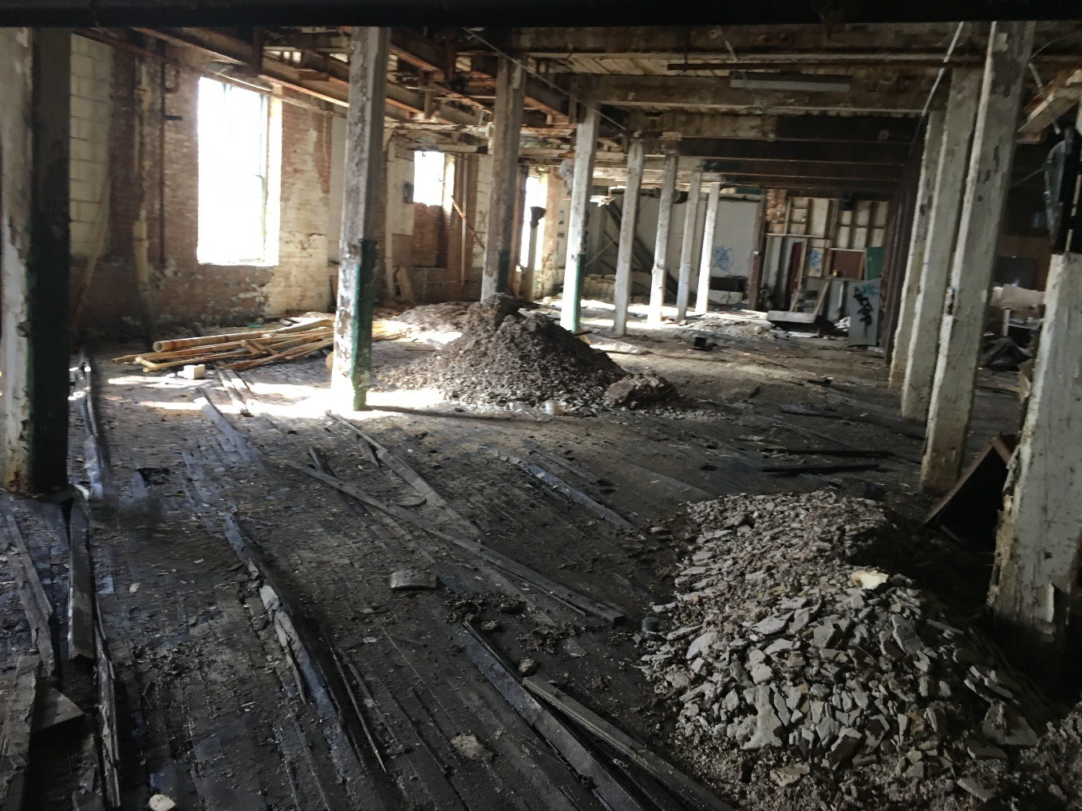

River Breeze Commons, 223 Canal Street - Site Remediation
CT DECD $ 865,000 City of Shelton $205,000
Total $1,070,000

- HBM Removal Final Use: 68 Housing Units
- Building Demolition Construction: Spring 2020
- Site Remediation Grant Close - Underway
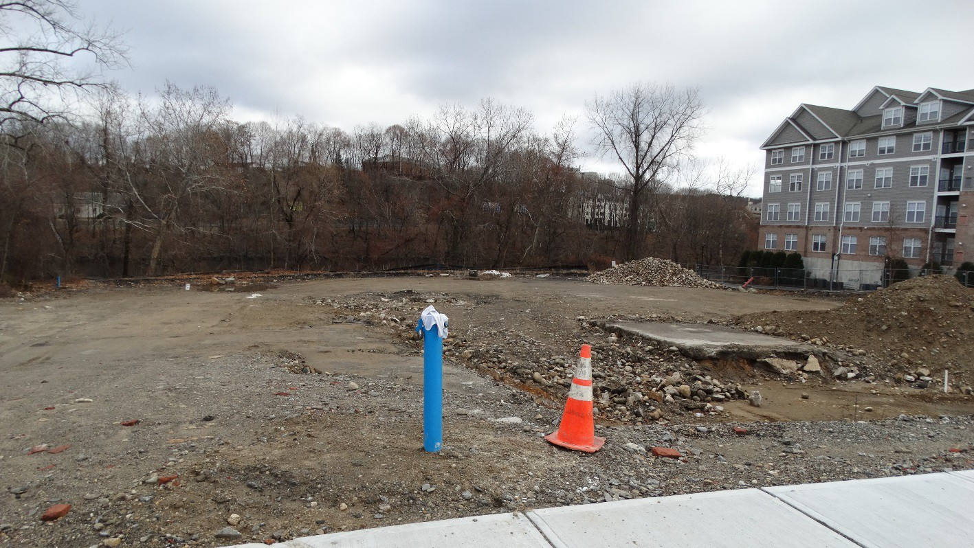

Canal Street Engineering – Phase V
Paul Grimmer stated that the contract was originally approved in June 2019. The engineers need to complete topographic surveys of Wooster Street and Canal Street. The cost for use activities were not within the bid as we expected that this work had already been done. The cost to produce this work is $6,000 and we are waiting on funding approvals from the City.

- Cardinal Engineering
- 1,400 Linear Feet
- Roadways, Sidewalks & Lighting
- Estimated Completion of Design - May 2020
- Next Step – Complete Topographic Survey of Project Area

US EPA – Community Wide Assessment Grant
APEX Tool
- Phase I Investigation - Completed
- Phase II – Subsurface Investigation - Completed
Autoswage Property
- Site Investigation Report – Completed
- Phase II / III Reports – Completed
- Final Report – Submitted for Review
- Closeout – 1st Quarter of 2020
Canal Street South
- Veterans Memorial Park, Shelton Farm & Public Market, Cel-lastik, & Chromium Process – Site
- Environmental Land Use Restrictions (ELURs)
- Long Term Groundwater Monitoring Plan

Slides were shown.

Apex Tool The Wharf Townhouses 235 Canal Street – Site Assessment
- GW Monitoring – Complete
- Soil Sampling – Complete
- 21 AOCs
- 60 sample intervals
- 200 soil samples
- Three GW wells
- Phase I/II Report – Delivered September 1st
- Very favorable results
- Developer submitted P & Z Application for residential use

AutoSwage 762 River Road – Site Assessment
- GW Monitoring – Complete
- Soil Sampling – Complete
- 25 AOCs
- 40+ Sample Location
- 150 Soil Analysis
- Seven GW Wells
- Waste/Sludge Impoundment Area (Lagoon) – Not Investigated
- Minor Remediation Issues – Outstanding

US EDA - Naugatuck Valley Economic Development Comprehensive Economic Development Strategy
- Shelton Economic Development Corporation
  - Lead Agency responsible for carrying out grant objectives and financial management.
  - 20 Regional Partnership
  - Sheila O’Malley, Chairperson of NVEDD Strategy Committee (Ansonia)
  - Valley COG – Provides additional support and resources
  - DeCarlo & Doll, Inc. - Consultant

Shelton Economic Development Corp. Future Ventures

Canal Redevelopment/Restoration
- Discontinue the Canal / Expand Parking Opportunities
- Remove Overgrow, Fill Canal and Develop Parking or Other Public Amenity
- Canal Lock – Historic Renovation
- Source of Funding (TBD – CT DECD / SHPO / OPM)

Downtown Redevelopment Planning
      - Target Area: Wooster Street to Kneen Street
      - Planning – Traffic, Parking, Lighting, Infrastructure / Streetscape Upgrades
      - Source of Funding (US EDA – Technical Planning Grant – Up to $200,000)

Communitywide Assessment/Planning
- Site Assessment Ascom Hasler / Wilkinson Paper Mill Property
- Veterans Memorial Park – Filing of Environmental Land Use Restriction / Closeout
- Source of Funding (US EPA Funds / City of Shelton)

Constitution Boulevard
- Transportation Engineering / Road Construction
- Source of Funding (US EDA – Project Funding – Up to $1,000,000)

Shelton Canal Restoration/Redevelopment
            - Public Infrastructure – Road Expansion, Sidewalks, Lighting, Parking
            - Environmental Restoration / Awareness - Pocket Park, Walking Trails, Improvement of Water Quality
            - Historic Preservation of the Shelton Canal Lock

Additional slides were shown of the canal and the canal locks.

Raymond P. Lavietes Award - Patrick Carey, 1st Vice Chairman

It is with great pleasure to present on behalf of the Shelton Economic Development Corporation this year’s Raymond P. Lavietes Award to the family of Sue Coyle for her many years of dedicated service to the SEDC, the Valley community and the City of Shelton. Gone but not forgotten. Thank you Sue!

Closing Remarks Mayor Mark A. Lauretti

Mayor Mark A. Lauretti thanked the stalwarts that braved the foul weather to attend the annual meeting. He stated that t showed to dedication to support of the organization, and the City as they work together to accomplish the economic development goals of the Downtown.

ADJOURNMENT -

The meeting adjourned at 9:30 AM.

Respectfully submitted,

Aleta Miner for Fred Ruggio, Secretary

